

**TECHNICAL UNIVERSITY OF KENYA**

**FACULTY OF APPLIED SCIENCES AND TECHNOLOGY**

**SCHOOL OF COMPUTING AND INFORMATION TECHNOLOGY**

**DEPARTMENT OF COMPUTER SCIENCE AND INFORMATICS**

**BLOCKCHAIN-BASED VOTING SYSTEM FOR KENYA AIRWAYS SHAREHOLDERS**

**PRESENTED BY:**

MICHAEL ORINA

SCII/00825/2019

**SUPERVISED BY:**

MR. SHADRACK MUGO

MR. BENARD MOKUA

**PROPOSAL SUBMITTED TO THE SCHOOL OF COMPUTING AND INFORMATION TECHNOLOGY IN PARTIAL FULFILLMENT FOR THE DEGREE IN BACHELOR OF TECHNOLOGY IN INFORMATION TECHNOLOGY PROJECT OF THE TECHNICAL UNIVERSITY OF KENYA**

**SUBMISSION DATE:** AUG 2023

**DECLARATION**

I declare that this project work as presented in this paper is my original work and has not been presented anywhere else for any degree, diploma or any other award.

Signature: Date:

____________ ______________

Approval

This paper was reviewed and approved by the following lecturers:

Mr. Shadrack Mugo

School of Computing and Information Technologies

Technical University of Kenya

Mr. Benard Mokua

School of Computing and Information Technologies

Technical University of Kenya

# 

# 

# 

**ACKNOWLEDGMENT**

Firstly, I would like to thank God for giving me this life and the ability to do this project. To my parents who have supported me in every means possible, I am forever grateful. To my supervisors who have given me new and fresh perspectives, Thank You. And finally, my friends who have criticized my work and given me ideas, thank you.

# 

Table of Contents

LIST OF TABLES 9

LIST OF FIGURES 10

ABBREVIATIONS 11

CHAPTER ONE: INTRODUCTION 12

1.1 Introduction: 12

1.2 Background of the Study: 12

1.2.1 Background 12

**1.2.2** **Overview of the Existing Systems** 14

**1.2.3** **Overview of the Proposed System** 14

1.3 Problem Statement: 15

1.4 Objectives: 16

**1.4.1** **Project Goal (Major Objective) Overall Goal:** 16

**1.4.2** **Specific Objectives:** 16

1.5 Justification: 16

1.6 Scope of the Study 17

1.7 Limitations of the Proposed System: 17

1.8 Project Risk and Mitigation: 18

1.9 Project Schedule: 18

1.10 Budget and Resources: 19

CHAPTER TWO: LITERATURE REVIEW 20

2.1 Reviewed Similar Systems 20

**2.1.1 Unstructured Supplementary Service Data (USSD) Code Voting System.** 20

**2.1.2 C & R System** 21

2.2 Tools and Methodologies Used in the Reviewed Systems 23

**2.2.1 USSD Code Voting System.** 23

**2.1.2 C&R System**. 24

**2.1.3 Computershare VMS System** 25

2.3 Gaps in the Existing Systems 26

2.4 The Proposed Solution 27

CHAPTER THREE: METHODOLOGY 28

3.1 Methodology and tools 28

**3.1.1 Methodology** 28

3.2 Source of Data 30

3.3 Data Collection Methods 31

3.4 Resources required / materials 32

CHAPTER 4: SYSTEM ANALYSIS AND REQUIREMENT MODELLING 33

4.1 Introduction 33

4.2 Objectives of the System Analysis 33

4.3 Problem Definition 33

4.4 Feasibility Study 33

**4.4.1 Technical feasibility** 34

**4.4.2 Economic feasibility** 34

**4.4.3 Operational feasibility** 34

**4.4.4 Schedule feasibility** 35

4.5 System analysis tools 35

4.5.1 Use case diagram 35

4.5.2 Flowchart 35

4.5.3 Entity Relationship diagram 35

4.6 System investigation 35

4.6.1 Introduction 35

4.6.2 Data collection 36

4.7 System analysis 38

4.7.1 Flowchart of the existing system 38

CHAPTER FIVE: SYSTEM DESIGN 40

5.1 Introduction to system design and nature of the system 40

5.2 Design Objectives 40

5.3 Program Design Tools 40

5.3.1 Flow chart 40

5.3.2 Use case 41

5.3.3 Data flow diagram 42

5.4 Logical Design 42

5.4.1 Logical data design 42

5.4.2 Entity life history 42

5.5 Physical Design Description 42

5.5.1 Data dictionary 42

5.5.2 Database Design 42

5.5.3 Input Screen 42

5.5.4 Output Screen 42

5.5.5 Code Design 43

CHAPTER SIX: SYSTEM IMPLEMENTATION 44

Introduction 44

6.1 Coding/Environment/Debugging Techniques. 44

**6.1.1 Coding tools** 44

**6.2.2 Environment** 44

**6.3.3 Debugging tools** 44

6.2 Program Listing 44

6.3 System/Program testing 44

6.4 Proposed Change-Over techniques 46

6.5 Test data 46

6.6 Sample Run- Output 47

CHAPTER SEVEN: USER MANUAL - DOCUMENTATION 48

7.1 Installation Environment 48

7.2 Installation Requirements 48

7.3 Installation Procedures 48

7.4 User Instructions 48

7.4.1 User login to the platform 49

7.4.2 Home page 49

7.4.3 User view results 50

7.4.4 User generate reports 50

7.4.5 User’s profile 51

7.4.6 Settings 51

7.5 System Conversion Method 52

7.6 User Training 52

7.7 File Conversions 52

CHAPTER EIGHT: LIMITATIONS, CHALLENGES, CONCLUSIONS AND RECOMMENDATIONS. 53

8.1 Limitations 53

8.2 Challenges 53

8.3 Degree of success 53

8.4 Learning experience 53

8.5 Recommendations 54

8.6 Conclusion 54

REFERENCES 55

APPENDIX 56

PRINT CODES 56

# LIST OF TABLES

Table 1.1 Budget and Resources 19

# 

# 

# 

# LIST OF FIGURES

Figure 1: Project Schedule 18

Figure 2: Agile Methodology 28

Figure 3:Pie-Chart 36

Figure 4:Flow-Chart of Existing System 39

Figure 5:Flow-Chart of Proposed System 41

Figure 6: Use-Case Diagram of Proposed System 41

Figure 7:Test Case 1 45

Figure 8: Test Case 2 45

Figure 9:Test Case 3 45

Figure 10:Test Data 46

Figure 11:Sample Run Output 47

Figure 12: User Login Page 49

Figure 13: User Voting Page 49

Figure 14: User View Results Page 50

Figure 15: User Report Page 50

Figure 16: User Profile Page 51

Figure 17: User Settings Page 51

Figure 18: Print Code 1 56

Figure 19: Print Code 2 56

Figure 20: Print Code 3 57

Figure 21: Print Code 4 57

# 

# ABBREVIATIONS

**CAGR** Compound Annual Growth Rate

**AGM** Annual General Meeting

**EGM** Extraordinary General Meeting

**USSD**  Unstructured Supplementary Service Data

**CDSC** Central Depository & Settlement Corporation

**PLC** Public Listed Company

**KCB**  Kenya Commercial Bank

**Q & A**  Question and Answer

**DFD**  Data Flow Diagram

**IDE** Integrated Development Environment

# CHAPTER ONE: INTRODUCTION

## 1.1 Introduction:

The process of voting in Kenya Airways is quite tedious for shareholders. One, because they have to review and understand extensive information in the proposed resolutions and two, due to the cost and security issues that arises with traditional voting methods.

Traditional voting methods is vulnerable to fraud and errors, making it difficult to ensure the accuracy and integrity of the voting process. Many shareholders often choose to vote by proxy, which requires them to appoint a representative to attend the annual general meeting and vote on their behalf. This process can be time consuming, as it requires shareholders to communicate with the proxy and ensure that the proxy will vote in line with their wishes.

With blockchain technology, a blockchain-based voting system offers a more secure and cost-effective solution. The decentralized nature of blockchain technology ensures that the voting process is tamper-proof, and the use of smart contract technology can automate the voting process.

This increases the trust and confidence of shareholders in the outcome of the process.

By implementing a blockchain-based voting system, Kenya Airways has the potential to provide a secure and transparent method for conducting voting.

## 1.2 Background of the Study:

## 1.2.1 Background

Kenya Airways Ltd., more commonly known as Kenya Airways, is the flag carrier airline of Kenya. The airline was owned by the Government of Kenya until April 1995, and it was privatized in 1996, becoming the first African flag carrier to successfully do so. Kenya Airways is currently a public-private partnership. The largest shareholder is the Government of Kenya (48.9%), with 38.1% being owned by KQ Lenders Company 2017 Ltd (in turn owned by a consortium of banks), followed by KLM, which has a 7.8% stake in the company. The rest of the shares are held by private owners; shares are traded on the Nairobi Stock Exchange, the Dar es Salaam Stock Exchange, and the Uganda Securities Exchange.

By virtue that the company is publicly traded and owned by private owners means that it holds AGM every year and carry out voting to determine various aspect of governance. This process is always hectic to the shareholders. The transparency, security and auditability of the process is almost an impossible idea due to various factors is place.

By implementing a blockchain-based voting systems which has been gaining attention in recent years as a potential solution to enhance the security and transparency of voting processes, we would be increasing the trust of the voting process. According to a report by Grand View Research, the global blockchain voting market size is expected to reach USD 441.5 million by 2025, growing at a compound annual growth rate (CAGR) of 61.5% from 2020 to 2025.

Blockchain technology, with its decentralized and secure ledger system, can provide a tamper-proof and transparent way of conducting elections and voting. In a blockchain-based voting system, votes are recorded as transactions on a decentralized ledger, making it nearly impossible for anyone to manipulate the results. The use of cryptographic algorithms and consensus mechanisms further enhances the security and accuracy of the voting process.

Blockchain technology has the potential to revolutionize the way voting systems are designed and implemented.

There is a significant potential for growth in the blockchain voting market in the coming years. The increasing demand for secure, transparent, and tamper-proof voting systems is one of the key factors driving the growth of the market. Blockchain technology is seen as a promising solution to address the challenges of traditional voting systems, such as fraud, manipulation, and low voter turnout.

### **1.2.2 Overview of the Existing Systems**

Voting in Kenya Airways is an essential process and the method used for voting can vary depending on different factors such as legal requirements of the Government of Kenya.

One common method of voting employed is in-person voting, where shareholders attend an Annual General Meeting (AGM) in person and cast their votes. In-person voting is often conducted using paper ballots, which are then counted manually or by electronic voting machines.

Another method employed in the past is proxy voting, where shareholders who cannot attend the meeting in person appoint a proxy to vote on their behalf. This can be done through various means, such as mail, email, or online, and the appointed proxy can be another shareholder, an attorney, or a representative of the corporation.

Remote voting is also an option in some cases, where shareholders can cast their votes from a distance by mail, email, or online. This method is often used for routine matters, such as electing directors or approving the annual budget.

Finally, hybrid voting, a combination of in-person and remote voting, allows shareholders to attend the meeting in person or participate remotely via video conferencing or other electronic means.

Specific procedures for voting in Kenya Airways are typically outlined in the corporation's bylaws or articles of incorporation. Moreover, these procedures may be subject to legal requirements and regulations of the Government of Kenya.

### **1.2.3 Overview of the Proposed System**

The proposed system will implement a blockchain-based voting system by leveraging the security and transparency features of blockchain technology to record and verify votes.

The corporation would set up a blockchain network with a specific set of rules and protocols for recording and verifying votes. The blockchain network is implemented on a secure online web portal. Shareholders or members of the corporation are given a unique identifier, called a personal access token, that allows them to cast their votes on the blockchain network. The online web portal is only accessible to authorized personnel that have logged in with their personal access tokens.

When a shareholder casts a vote, the vote is recorded on the blockchain as a transaction that is validated by a network of nodes or computers running the blockchain software. The vote is then added to a block of transactions that is cryptographically linked to the previous block, creating a chain of blocks that cannot be altered or tampered with.

Once all the votes have been recorded, the blockchain network can tally the results and verify that they are accurate based on the rules and protocols set up by the corporation. The results can then be made available to shareholders or members of the corporation, providing a transparent and auditable record of the voting process. The results of the votes would be available to download and print for the sake of record keeping.

Blockchain-based voting systems in corporations offer several advantages, including increased security, transparency, and efficiency compared to traditional voting systems.

## 1.3 Problem Statement:

“To develop a web-based application implemented on a blockchain platform that allows Kenya Airways shareholders to vote on proposed resolutions.”

The objective is to create a platform where Kenya Airways shareholders can securely and transparently participate in the voting process. The blockchain technology ensures that the voting data cannot be tampered with, providing a high level of trust and accountability. The web-based application makes it convenient for shareholders to access and participate in the voting process from anywhere with an internet connection.

## 1.4 Objectives:

### **1.4.1 Project Goal (Major Objective) Overall Goal:**

To develop a web-based application implemented on a blockchain platform that allows Kenya Airways shareholders to vote on proposed resolutions.

### **1.4.2 Specific Objectives:**

1. To design an intuitive user-friendly web-based interface.
2. To develop interactive voting elements such as buttons, checkboxes, and progress indicators.
3. To implement smart contracts that automate vote recording, tallying, and result generation.
4. To ensure mobile responsiveness by designing the interface to be responsive and adaptable across various devices.
5. To design shareholder profiles with relevant information and historical voting records.

## 1.5 Justification:

The system will provide the following benefits to the Kenya Airways Shareholders:

Improved Corporate Governance by reducing the potential for fraud and conflicts of interest which enhances the trust and confidence.

Enhanced Security by making it impossible to manipulate the voting results, which reduces the risk of frauds and cyber-attacks.

Improved Efficiency by eliminating the need for intermediaries, paper-based documentation, and manual vote counting, reducing the administrative burden on the organization.

Alignment with Technology Trends as blockchain technology is gaining wider adoption in various industries and sectors.

Improved shareholder satisfaction by enabling participation in decision making processes.

## 1.6 Scope of the Study

The project would cover the following areas:

**Identification of shareholders** by implementing a connect to wallet where each shareholder would have a unique address.

**Review** the information and proposed resolution to be voted on.

Cast votes.

The votes would be **recorded** on the blockchain platform in a tamper-proof manner, ensuring the integrity of the voting process.

Automated vote **counting** process.

Real-Time **display** of results.

The system would also include a way for shareholders to **download and print** the voting results for record keeping.

The system would not cover the following areas:

**Shareholder engagement** by driving engagement or participation in the voting process.

**Non-voting matters** such as discussions or presentations, would not be within the scope of the system.

**Technical issues** outside the system such as internet connectivity issues or hardware malfunctions on a shareholder's device.

## 1.7 Limitations of the Proposed System:

Like any voting system, this has several potential limitations and drawbacks which includes:

**Cost**. Implementing and maintaining a blockchain-based voting system is expensive.

**Scalability.** The performance and scalability of a blockchain-based voting system may be limited, especially if many users are participating in the system simultaneously

**Legal and regulatory challenges.** The system may be subject to various legal and regulatory requirements of the Government of Kenya.

## Project Risk and Mitigation:

**Technical challenges.** Developing and implementing a blockchain-based voting system requires a high level of technical expertise.

This is solved by extensive study and consulting with those that are experienced in the field.

**Resistance to change**. Introducing a new voting system may face resistance from shareholders who are accustomed to traditional voting methods.

This is solved by conducting an extensive communication and education campaigns to inform stakeholders about the benefits of the new system and address their concerns.

Laptop devices might **crash** or infected with a computer **virus**.

This is solved by implementing multiple nodes or computers that can be used to validate and store the blockchain data, ensuring that the system can continue to function even if one node or computer is compromised.

## 1.9 Project Schedule:

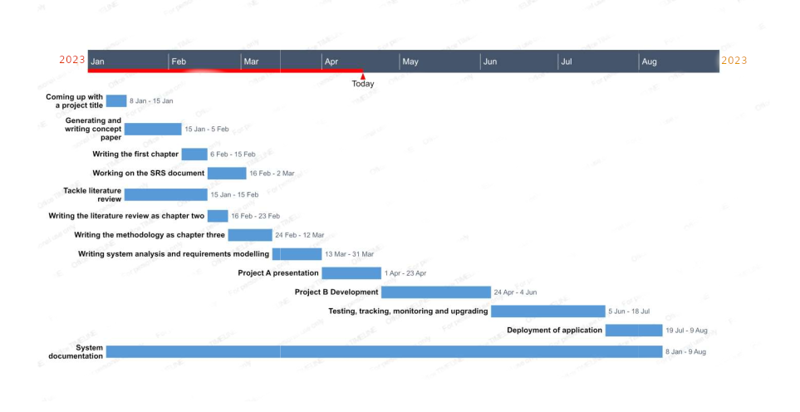

Figure : Project Schedule

## 1.10 Budget and Resources:

| RESOURCES | DESCRIPTION | SPECIFICATIONS | UNITS | PRICE |
| --- | --- | --- | --- | --- |
| Laptop | For doing the project, coding the web-based application | Minimum requirement of Core i5, RAM 8 GB and storage space of 500 HDD | 1 | Ksh 40,000  (Available) |
| Mobile phone | To do testing | Smartphone | 1 | Ksh 20000 |
| Internet access | To facilitate access to online features | At least 30mbps | - | Ksh 4500 per month |
| Cloud Storage Backup | To back up progress in case of crash failure | At least 20 GB | - | Ksh 3000 |
| Miscellaneous | Typing, printing cost  throughout the  project | - | - | Ksh 5,000 |
|  |  |  |  | Total = 72, 500 |

Table .1 Budget and Resources

# CHAPTER TWO: LITERATURE REVIEW

As of the year 2023, the Nairobi Securities Exchange (NSE) boasts a total of 62 publicly listed companies, which are categorized into 13 distinct sectors, according to the data sourced from the NSE website. Each of these companies conducts an Annual General Meeting (AGM) where the senior leadership meets with shareholders to deliberate on the company's performance. In this section, we will delve into the various voting systems utilized by Kenya Airways to provide actionable solutions to mitigate errors and improve effectiveness of the systems.

## 2.1 Reviewed Similar Systems

### **2.1.1 Unstructured Supplementary Service Data (USSD) Code Voting System.**

The company Act 2015, was amended to permit companies to convene and conduct a virtual general meeting. USSD voting is a type of mobile voting system that allows shareholders to cast their votes on resolutions using their mobile phones via a USSD code. In Kenya Airways, the USSD code for voting is *384*040.

Shareholders wishing to participate in the meeting, register for the AGM by dialing the USSD code for all networks and following the various prompts regarding the registration process. They should have the ID/Passport they used to buy the shares and/or the CDSC Account number. The registration period comes prior to the AGM on a specified timeframe. Registered shareholders can ask questions via the USSD code by selecting the option ask questions.

USSD voting is typically used during Annual General Meetings (AGMs) and Extraordinary General Meetings (EGMs) where shareholders are required to vote on various issues such as the election of directors, appointment of auditors, approval of financial statements, and any other matters that may require shareholder approval.

The AGM is streamed live via a link which is provided to all registered shareholders. They can then vote (When prompted by the chairman) via the USSD prompts. Once the vote has been cast, the shareholder receives a confirmation message indicating that their vote has been recorded.

USSD voting is beneficial to both shareholders and companies. For shareholders, it eliminates the need to physically attend meetings, which can be time-consuming and expensive, especially for those who live far away from the venue. It also provides a transparent and efficient voting process that ensures that their votes are accurately recorded and counted.

For companies, USSD voting increases shareholder participation and engagement, which is essential for good corporate governance. It also reduces the administrative burden associated with traditional paper-based voting systems, which can be cumbersome and prone to errors.

In conclusion, USSD voting is a valuable tool that is uses by Kenya Airways to improve shareholder participation and engagement. It provides a convenient and cost-effective way for shareholders to cast their votes remotely, while also promoting transparency and good corporate governance in the organization.

### **2.1.2 C & R System**

C&R is a long-term client relationships system share registrar managed by C&R Group. It specializes in providing end-to-end solutions for the efficient management of AGMs for Kenya Airways and other companies listed on the NSE. The system offers a comprehensive range of services that aid in the voting process during AGMs, ensuring that shareholders can conveniently and easily participate in company decisions

The system has a secure and user-friendly online voting platform which allows shareholders to cast their votes remotely, from anywhere in the world, using a computer or mobile device. The system ensures that votes are accurately recorded and counted, and provides real-time updates on the voting process.

Additionally, it offers a USSD voting platform, which is a type of mobile voting system that allows Kenya Airways shareholders to cast their votes using their mobile phones via a USSD code provided by the company. This system provides a convenient way for shareholders to participate in company decisions remotely, especially for those who may not have access to the internet or a computer.

It also provides comprehensive support services to companies during the AGM process. This includes managing the registration of shareholders, verifying their identities, and ensuring that they are provided with all necessary information and documentation. It also provides technical support and troubleshooting during the voting process, ensuring that any issues or errors are resolved in a timely manner.

In addition to electronic voting, C&R also provides other value-added services, such as pre-AGM registration, live streaming of the AGM, and data management. These services aid in the organization and management of AGMs, ensuring that the process is seamless and efficient.

Overall, C&R aid voting in AGMs for Kenya Airways by providing convenient, efficient, and secure methods for shareholders to participate in company decisions. It also ensures that the AGM process is well-managed and that all shareholders are provided with equal opportunities to vote and have their voices heard.

**2.1.3 Computershare Virtual Meeting System.**

Computershare VMS is an Australian stock transfer system that provides corporate trust, stock transfer, investor services for shareholders and employee share plan services in many countries. It has found its way to Kenya through ABSA Group Limited and is implemented by Kenya Airways in AGM voting processes.

Computershare's VMS provides Kenya Airways with a comprehensive solution for conducting Annual General Meetings (AGMs) and other important company meetings remotely. With this service, shareholders can participate in meetings from anywhere with an internet connection, without the need to attend in person.

One of the most significant benefits of Computershare's VMS is the advanced voting capabilities that allow shareholders to cast their votes on resolutions and proposals before or during the meeting. This feature ensures that all votes are accurately recorded and counted, promoting transparency and good corporate governance.

The virtual meeting platform also includes interactive features such as chat, polling, and Q&A sessions, which enable shareholders to engage with management and ask questions during the meeting. This can help to foster shareholder participation and engagement, which is essential for good corporate governance.

Computershare's virtual meeting services are designed to be user-friendly and secure, with professional support from experienced meeting coordinators who ensure that the meeting runs smoothly and efficiently. The platform also includes recording and archival capabilities, which enable companies to record and archive virtual meetings for future reference.

Overall, Computershare's virtual meeting services provides Kenya Airways with a convenient and cost-effective way to hold meetings remotely, while also promoting transparency, shareholder participation, and good corporate governance.

## 

## 2.2 Tools and Methodologies Used in the Reviewed Systems

### **2.2.1 USSD Code Voting System.**

This program uses USSD codes: This is the primary tool used in USSD voting. It is a code that is dialed by shareholders on their mobile phones to access the voting system. The USSD Code used by Kenya Airways is *384*040#.

The voting system is delivered through mobile networks, such as Safaricom and Telkom, which must be reliable and secure to ensure that the voting process is efficient and accurate. Shareholders may also receive SMS notifications with information on how to access the voting system and reminders to participate in the voting process.

Robust backend systems are required to manage the voting process and ensure that all votes are accurately recorded and counted. USSD voting systems must also have strong security protocols in place to protect against fraud and unauthorized access. Data analytics is an important component of USSD voting systems, as they generate data that can be analyzed to gain insights into shareholder participation and engagement. This data can be used to improve future voting processes and promote good corporate governance.

In summary, USSD voting systems rely on a combination of technology and methodology to ensure that the voting process is convenient, efficient, and transparent for shareholders. By leveraging these tools and methodologies, publicly listed companies can improve shareholder participation and engagement while promoting good corporate governance.

#### Pros

**Convenience.** USSD voting systems provide a convenient way for shareholders to participate in voting processes without having to physically attend meetings. Shareholders can cast their votes from anywhere at any time using their mobile phones, which saves them time and money.

**Increased participation**. USSD voting systems increase shareholder participation in voting processes by making it easier for them to cast their votes. This promotes good corporate governance by ensuring that all voices are heard and that decisions are made in the best interest of the company.

#### Cons

**Limited functionality.** USSD voting systems have limited functionality compared to other voting systems. They are primarily designed for simple yes/no or multiple-choice questions, which may not be sufficient for more complex voting scenarios.

**Lack of security.** While USSD voting systems have security features such as one-time passwords and encryption, they may still be vulnerable to hacking or other types of cyber-attacks. This could compromise the integrity of the voting process and potentially impact the outcome of the vote

**Cost.** While USSD voting systems are generally more cost-effective than traditional voting systems, they still require some investment in terms of infrastructure and maintenance.

**Network connectivity issues.** USSD voting requires a stable and reliable network connection. If there are connectivity issues or network outages, shareholders may not be able to participate in the voting process, leading to potential disenfranchisement.

### **2.1.2 C&R System**.

The C&R System provides an electronic voting platform that allows shareholders to vote remotely using their mobile phones, computers or other devices that provides an efficient way for shareholders to participate in the voting process. It assists companies in soliciting proxies from their shareholders by encouraging shareholders to vote by proxy.

C&R System also helps companies to communicate effectively with their shareholders. This includes sending out notices of the AGM, providing information on the voting process, and answering any questions shareholders may have.

#### Pros

Provides **comprehensive** AGM management services

Offers **customized** solutions to meet specific client needs

Provides a range of **electronic voting platforms**, including USSD, SMS, and online voting

Enhances **shareholder engagement** and participation in AGMs

#### Cons

Increased **costs** for companies

Potential **technical difficulties** or malfunctions during the voting process

Limitations in **accessibility** for shareholders who may not have access to mobile devices or internet services

**Security Issues.** The system may be vulnerable to hacking or other types of cyber attacks which could compromise the integrity of the voting process.

### **2.1.3 Computershare VMS System**

Computershare VMS uses a range of tools and methodologies to ensure that shareholders can participate in meetings remotely. One of the primary tools used is the webcasting platform, which allows shareholders to watch the meeting live from their computer or mobile device. The platform is designed to provide high-quality video and audio streaming, as well as interactive features that allow shareholders to ask questions and participate in discussions in real-time.

Another important tool used by Computershare Virtual Meeting Services is the online voting system. This system enables shareholders to cast their votes remotely through a secure online portal. The system is designed to be user-friendly, with a simple interface that allows shareholders to easily navigate through the voting options and cast their votes on various proposals or resolutions.

#### Pros

Computershare VMS allows for **real-time communication** between shareholders and the company's management, providing an avenue for shareholders to ask questions and provide feedback during the meeting.

It provides a **cost-effective** solution to traditional AGM voting methods, which require shareholders to physically attend the meeting venue.

#### Cons

**Technical issues**. The system relies heavily on internet connectivity and may experience technical glitches such as poor video quality, delayed audio, or even disconnections which can affect the voting process.

**Security concerns.** Virtual meetings may be susceptible to cyber-attacks or hacking attempts, which could compromise the integrity of the voting process and affect the outcome of the AGM.

## 2.3 Gaps in the Existing Systems

USSD voting is a convenient and cost-effective way for Kenya Airways shareholders to cast their votes on proposed resolutions. However, the system is not entirely **secure**, as it can be vulnerable to hacking, and there is a risk of vote manipulation. USSD voting is prone to errors due to network connectivity issues and may not be accessible to all shareholders who do not have a registered mobile phone. Additionally, USSD voting does not provide a completely transparent voting process, as the data can be easily altered and is not easily auditable.

One problem with the C&R System is **transparency**, it relies on manual vote counting and result tabulation, which can be prone to errors or tampering. This process can be time-consuming, which may delay the announcement of the results, and there may be limited visibility into the vote counting process. In addition, there is a risk of voter impersonation, which could undermine the integrity of the voting process.

It may also not provide **real-time access** to vote tallies and results to all shareholders. This could lead to questions about the accuracy and fairness of the voting process, particularly if there is a delay in the announcement of the results. In some cases, there may be limited information provided to shareholders about how their votes were counted or how the results were reached.

**Auditing** the voting results is also a challenge. While Computershare does provide some auditing services, it can be difficult to conduct a comprehensive audit of the voting results due to the large volume of votes cast and the complexity of the voting process. This can make it difficult to identify and address any errors or issues that may arise, which could impact the outcome of the vote.

## 2.4 The Proposed Solution

The proposed solution to the above challenges includes:

Implementing the system using **blockchain technology**. The new system will leverage blockchain technology to ensure transparency, security, and immutability of the voting process.

Use of smart contracts to **automate** the vote counting process.

**Real-time voting results.** The system will provide real-time voting results that are publicly accessible, ensuring transparency and accountability.

**Immutable audit trail.** The blockchain technology employed in the system will create an immutable audit trail that can be used to verify the accuracy of the voting process.

**Decentralized system.** The new system will be decentralized, meaning that it will not be controlled by any central authority. This will ensure that the voting process is not influenced by any external factors.

**Accessibility.** The system will be accessible to all eligible voters, regardless of their location, using any internet-enabled device.

**Ease of use.** The new system will be user-friendly and easy to navigate, ensuring that even non-technical users can participate in the voting process without any difficulties.

**Scalability.** The system will be designed to handle a large number of voters and votes, ensuring that it can be used for both small and large-scale voting processes.

# CHAPTER THREE: METHODOLOGY

## 3.1 Methodology and tools

Methodology refers to the overall approach or framework used to plan, execute, and manage a research project. It includes the processes, procedures, and techniques used to achieve the research objectives. Methodologies provide a structured approach to research and typically include phases, such as problem identification, literature review, research design, data collection, data analysis, and conclusions.

This chapter will focus on the methodology I will use in my project and the various tools I intend to use to analyze data.

### **3.1.1 Methodology**

For this project, Agile Methodology will be used. It is an iterative and flexible approach that emphasizes continuous improvements.

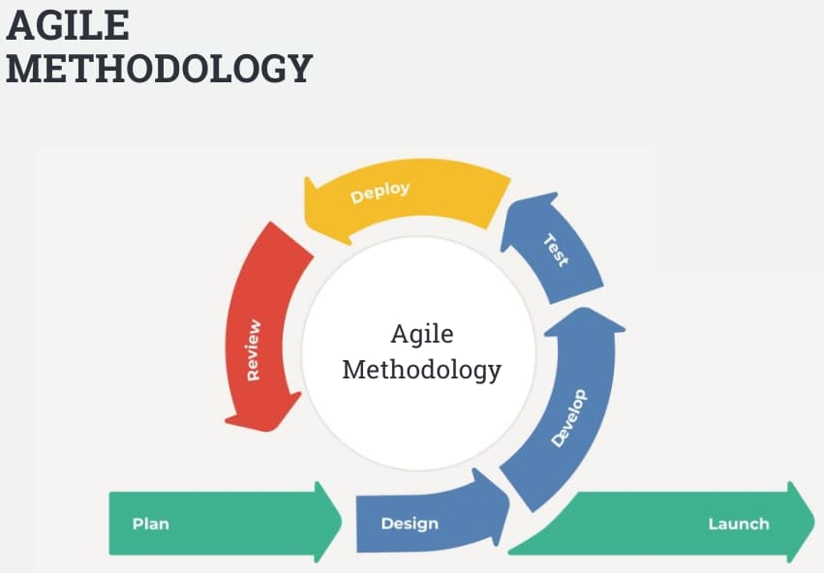

Figure : Agile Methodology

The methodology consists of the following phases:

1. Plan

This is the initial Phase that sets the foundation of the entire project. The project objectives, scope and requirements are defined and the project roadmap is created. Requirements are analyzed to determine the feasibility of the project.

1. Design

This phase involves designing and prototyping the product. A functional design that meets users’ needs is created. This phase is an iterative phase where there is continuous improvement and design based on feedback and testing.

1. Develop

This phase involves actually developing the product in sprints focusing on developing a working increment of the software product. There is testing with a focus on catching and fixing any issues early in the development process.

1. Deploy

This involves deploying the product to production or releasing it to end-users. The Deploy phase is the final stage in the development process and involves testing the product in a live environment.

1. Review

Review involves reviewing and evaluating the product's performance and the development process. It occurs at the end of each sprint and includes both a retrospective and a demo. The Review phase is an essential component of the Agile methodology, as it allows continuous improvement of the product and the development process.

1. Launch

The Launch phase involves releasing the product to the market or to end-users. It includes ongoing monitoring and maintenance to ensure that the product remains up-to-date and meets the user's needs.

Reasons for using agile methodology:

**Flexibility.** Agile methodology is designed to be flexible and adaptable to changing circumstances. In a research project, this can be particularly important, as the project may involve uncertainty or unexpected findings.

**Iterative approach.** Agile methodology involves an iterative approach, with regular review and feedback sessions which can be valuable, as it allows refinement and improvement of the research as I go.

**Focuses on delivering value.** Agile methodology focuses on delivering value to the end-user. This ensures that the research is designed to address the respective needs and priorities.

**3.1.2 Tools to be used in the methodology**

This methodology will be able to utilize a number of tools to show the conceptual and logical

flow of the processes in the application.

1. Flowcharts. It uses symbols and diagrams to illustrate the steps in a process and the relationships between them, providing a clear and concise way to understand how a system works. Flowcharts will be used to analyze and optimize processes, identify bottlenecks and inefficiencies, and communicate complex information in a simple and easy-to-understand format.
2. Use Case Diagrams. It will be used as a visual representation of the interactions between actors (users or systems) and the system. It will be used to provide a high-level overview of the system's functionality and to identify the different types of users or stakeholders involved.
3. Data Flow Diagrams. A Data Flow Diagram (DFD) will be used as a tool to represent the flow of data within a system or process. The DFD will be a valuable tool for identifying areas for optimization and improving the overall efficiency and effectiveness of the system.

## 3.2 Source of Data

In order to accomplish the task at hand, it is vital to collect data from different sources both primary and secondary data.

Primary Data

A primary source of data is original information collected directly from the source. It can include surveys, interviews, experiments, observations, or other firsthand accounts of events or phenomena.

Secondary Data

A secondary source of data is information that has been collected and analyzed by someone else. It includes published works, such as books, journals, and reports, as well as data from online sources and databases.

## 3.3 Data Collection Methods

To ensure that the data collected will be accurate and relevant, I will use the following methods for data collection:

1. Questionnaires. It will entail me designing a set of questions to be administered to a group of respondents in order to collect data. This method of data collection is commonly used in surveys and can provide valuable information on attitudes, beliefs, and behaviors. By carefully constructing the questionnaire and selecting a representative sample of respondents, I can obtain accurate and reliable data that can help inform research or decision-making processes.
2. Observation. It will entail me observing and recording events or behaviors as they occur in a natural or controlled environment. This method of data collection can provide valuable insights into human behavior, social interactions, and the environment. By carefully documenting observations, I can identify patterns, behaviors, and other relevant information that can help inform research or decision-making processes.
3. Interviews. It will entail me conducting face-to-face or virtual conversations with individuals or groups to collect data. This method of data collection can provide in-depth information on attitudes, beliefs, experiences, and opinions.
4. Literature Review. It will entail me reviewing published literature, such as books, journals, and reports, to collect data. This method of data collection can provide valuable insights into the current state of research on a particular topic, identify gaps in knowledge, and inform future research directions. By carefully selecting and analyzing relevant literature, I can obtain a comprehensive understanding of the research topic and use it to inform research or decision-making processes.

## 3.4 Resources required / materials

Hardware Specifications

* Laptop - Used as the working platform for this project
* Processor speed – Intel (R) Core i5 ,2.60GHz
* Memory requirements – Minimum of 4 GB RAM.
* Hard disk capacity – Minimum of 500 GB.

Software Specifications

* VSCodium - VSCodium is a free and open-source code editor that is based on the Visual Studio Code (VS Code) editor by Microsoft. It is designed for developers who prefer a fully open-source development environment.
* Frontend development tools - I will use NextJS to develop my front end.
* Backend development tools - They will include, NodeJs(provides the runtime environment for executing JavaScript code on the server-side), firebase (To authenticate users).
* Remix IDE - To write smart contracts that would implement the blockchain technology.
* Software configuration management tools – Include github and vercel to track

changes in the software.

* Operating System – ParrotOS

# CHAPTER 4: SYSTEM ANALYSIS AND REQUIREMENT MODELLING

## 4.1 Introduction

In the evolution of Kenya Airways' shareholder interactions, the infusion of blockchain technology stands as a transformative force. This chapter delves into pivotal aspects of the project: system analysis and requirement modeling. With a focus on optimizing the voting system, the project aims to enhance shareholder engagement through streamlined and secure processes. By dismantling traditional barriers and embracing decentralization, the envisioned system embodies transparency, efficiency, and operational viability.

This chapter uncovers the path from existing limitations to a tamper-proof voting ecosystem, set to empower Kenya Airways shareholders and elevate decision-making.

## 4.2 Objectives of the System Analysis

The major objective of system analysis is to understand how things are currently being done and what improvements are needed. It will help in building the new proposed system that will better meet the users’ needs and satisfaction.

It aids to identify inefficiencies in the existing shareholder voting process and develop a secure, transparent, and user-friendly blockchain-based system to enhance shareholder engagement.

## 4.3 Problem Definition

The current manual shareholder voting process at Kenya Airways lacks transparency, is time-consuming, and prone to errors, prompting the need for a blockchain-based solution to revolutionize and streamline the voting experience.

## 4.4 Feasibility Study

The feasibility study evaluates the practicality and viability of implementing the blockchain-based voting system, considering technical, operational, economic, and schedule aspects. This assessment ensures that the proposed solution aligns with Kenya Airways' goals, resources, and constraints.

### **4.4.1 Technical feasibility**

This was carried out to ensure that the hardware, software and other requirements on technology required to deliver the project were available. The technical requirement for the proposed system are as follows:

Hardware Requirements.

* 1. A laptop – for the coding of the mobile application which will have a minimum of core i7 processor, RAM 16GB, SSD 500GB.
  2. Ethernet cable- for internet access.
  3. Mobile phone- an android handset to use for testing of the application.
  4. USB cable – for connecting the mobile phone and laptop

Software

i.VSCodium - An open-source IDE for coding

ii.ParrotOS for the laptop

### **4.4.2 Economic feasibility**

The economic feasibility analysis involves assessing the costs of developing and supporting the blockchain-based voting system for Kenya Airways shareholders, comparing these costs with anticipated benefits. The benefits include enhanced shareholder engagement, streamlined decision-making, and potential cost savings, forming the rationale for the project's investment.

### **4.4.3 Operational feasibility**

The operational feasibility evaluation focuses on the transition from manual voting to a blockchain-based system for Kenya Airways shareholders. This assessment ensures that the proposed solution aligns with the airline's operations and aims to improve efficiency by reducing errors, eliminating physical constraints, and enhancing shareholder participation in the voting process.

### **4.4.4 Schedule feasibility**

The schedule feasibility assessment considers the project's ambitious timeline of implementing the blockchain-based voting system for Kenya Airways shareholders within a short span of 4 moths. This evaluation examines the feasibility of timely development and deployment while ensuring quality and functionality, highlighting the need for efficient project management and utilization of appropriate technologies.

## 4.5 System analysis tools

### 4.5.1 Use case diagram

A system analysis tool used to capture the functional requirements of the system while showing the user’s interaction with the system. The actor of this system is the user who is the shareholder or the admin.

### 4.5.2 Flowchart

This is a system analysis tool that I will use to show the steps in sequential order. It will therefore, present the flow of algorithms, workflow or processes of the proposed web application.

### 4.5.3 Entity Relationship diagram

I will use an ER diagram to explain the logical structure of the database of the proposed system. ER diagrams are created based on three basic concepts entities, attributes and relationships. They will be used to give a visual representation of different data using conventions that describe how these data are related to each other.

## 4.6 System investigation

### 4.6.1 Introduction

This is the process of finding out what the proposed system is being developed to do and if it is feasible. The analysis is done to ensure that the proposed system does the work the existing system does and even more innovative. The proposed system should be able to fulfill all the functions it is expected to have. The process of system investigation is done using the various available techniques such as questionnaires, interviews, observation of the current system operations and surveys. The results of this technique give necessary data to be used in building and developing the proposed new system.

### 4.6.2 Data collection

Data was gathered and analyzed using various methods. The sample set used in the research was a definitive part of the population expected to use the application. The techniques I used to collect data were, interviews, questionnaires and observation.

#### 4.6.2.1 Questionnaire

#### I collected data for this project using questionnaires created using Google Forms and shared online via social media platforms. I also issued the questionnaires to the shareholders and admins of the Kenya Airways. I used open and closed questions. The figures 25 and 26 at the appendix show the questions that were asked. The questionnaire got 60 respondents. The questionnaire was administered online and the feedback from the respondents were as reported below. I used pie charts to record the response from the questionnaires.

#### 

Figure :Pie-Chart

#### 4.6.2.2 interview

I conducted an in-depth interview to the key informants of the proposed system. I conducted the interview at the Kenya Airways grounds. At the appendix there is the interview guide I used to conduct the interview.

Data was collected through a recorded face to face interview to 3 interviewees. I interviewed the admin. I used my phone to record the interview sessions. From his responses, there is need to incorporate blockchain voting. With the growing use of technology an application

will be accepted easily.

Based on the responses and the whole data collection activity, it is evident that the there is no actively used application in the organization. Most of my assumptions were made from the interview as it was more interactive compared to the questionnaire.

#### 4.6.3 Fact recording

This is a recording of the system requirements. It will give a detailed definition of the system

requirements and specification of the project.

4.6.3.1 System requirements

The system requirements encompass the development of a user-friendly web application powered by Ethereum blockchain. This entails creating an intuitive interface for shareholders to cast their votes securely, ensuring compatibility with Kenya Airways' existing systems, and employing modern technologies such as Next.js, React, and Solidity to deliver a seamless and efficient voting experience.

It should enable shareholders to cast their votes remotely using a user-friendly web application.

The system should ensure the immutability of votes through blockchain technology, offer real-time updates on voting progress, and provide an auditable record of all voting activities.

Additionally, it should streamline the voting process, enhance shareholder engagement, and contribute to more informed and efficient decision-making for the airline.

The systems non-functional requirements are:

i.User-friendly – The application user interface should be simple and easy to use

ii. Interactivity – The application prompts for input where needed and validates the format of the input.

iii. Performance – The application performs its operations effectively and efficiently.

iv. Adaptability – The application should integrate their different features seamlessly.

v.The system will be available 24/7.

4.6.3.2 Input requirements

The input requirements for the blockchain-based voting system include shareholder identification (such as unique IDs), authentication credentials, and the voting choice. Additionally, the system may require timestamps to ensure voting deadlines are met. These input elements will be collected through the user-friendly web application interface, designed to facilitate easy and accurate input from shareholders participating in the voting process.

#### 4.6.3.3 Output requirements

#### The output requirements for the blockchain-based voting system encompass real-time confirmation of submitted votes, providing shareholders with immediate feedback on the status of their voting actions. The system should generate an auditable and tamper-proof record of all voting activities, accessible for auditing purposes. It should also display the aggregated results of the voting process once it's concluded, enabling Kenya Airways to make well-informed decisions based on the shareholders' collective input.

## 4.7 System analysis

This involves analyzing the program requirement in current and existing system to find out if requirements in the current system can be used in the development of the new system. The afore mentioned requirements are requirements of the proposed system in this project.

### 4.7.1 Flowchart of the existing system

This is the flow chart of the current and existing system.

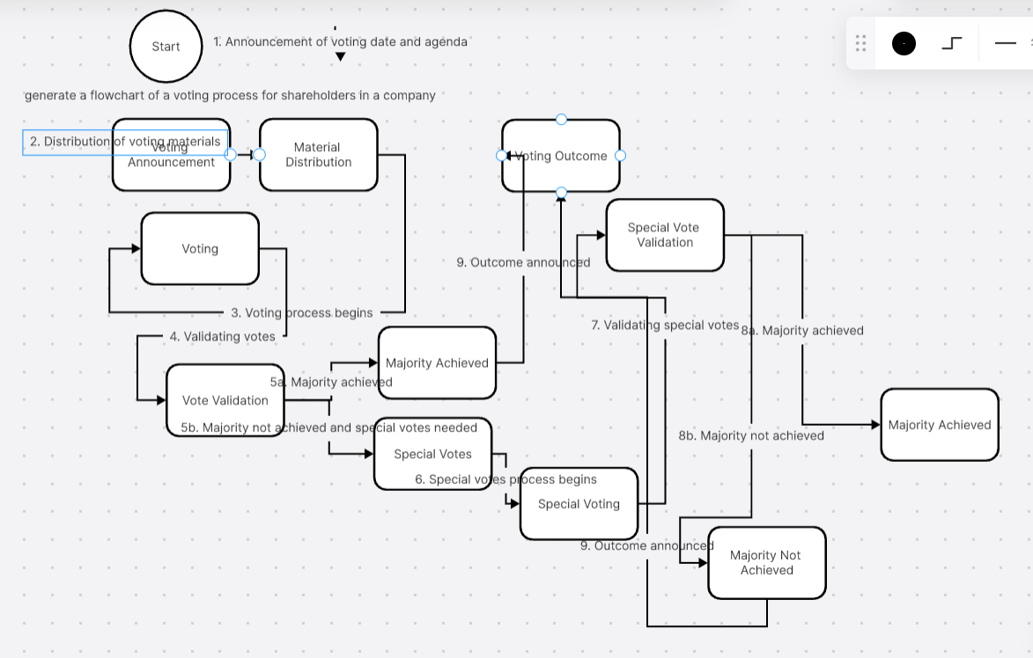

Figure :Flow-Chart of Existing System

# CHAPTER FIVE: SYSTEM DESIGN

## 5.1 Introduction to system design and nature of the system

System design is the step where we turn ideas into a detailed plan. In our case, it's about creating a clear structure for the blockchain-based voting system for Kenya Airways shareholders. This plan shows how different parts work together to make voting secure and easy. The system's essence is using computers to connect shareholders and the voting process. With blockchain, we ensure that all votes are recorded securely and can't be changed. This chapter explains how we're putting all these ideas into action to make the system work smoothly.

## 5.2 Design Objectives

While designing the application, the following are the expected design objectives that it should meet;

1. **User-Centric Interface** bydesigning an intuitive and user-friendly interface that allows shareholders to easily navigate the system and cast their votes.
2. **Immutable Data Integrity** by developing a system architecture that integrates blockchain technology.
3. **Responsive Multi-Device Access** that adapts seamlessly to various devices

## 5.3 Program Design Tools

These are the tools to be used in designing the application. They are the same tools discussed in chapter three, methodology.

### 5.3.1 Flow chart

This is the flow chart of the proposed web application. A graphical representation of the sequence of events in the system. It describes the flow of events from launch of the application, through the execution of tasks up to the completion of tasks and ending of the application.

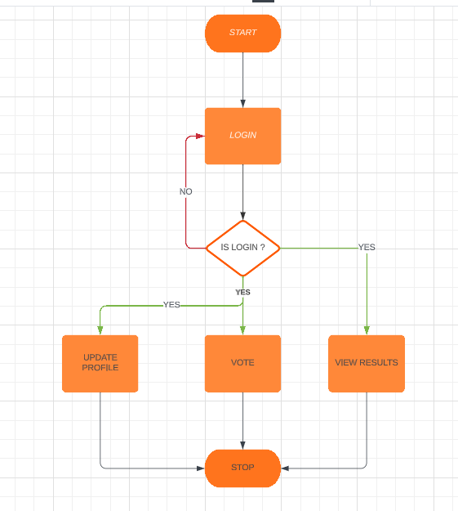

Figure :Flow-Chart of Proposed System

### 5.3.2 Use case

This is the use case of the proposed web application. This system analysis tool is used show a graphical visualization of the user interaction with the developed system.

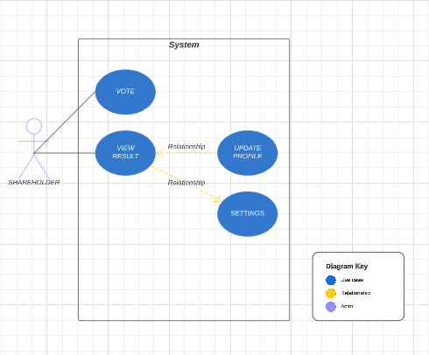

Figure : Use-Case Diagram of Proposed System

### 5.3.3 Data flow diagram

This is the data flow diagram of the proposed web application. This tool is used to show the flow of data in the system.

## 5.4 Logical Design

### 5.4.1 Logical data design

A logical design is a conceptual, abstract design hence is developed after the conceptual model. It entails defining the types of information that will be needed. The process of logical design involves arranging data into a series of logical relationships called entities and attributes. This involves data modelling which is the first and essential process for database design. In logical design, the identified data and their relationships are mapped into a data schema for the underlying DBMS (Database Management System).

### 5.4.2 Entity life history

According to Beynon-Davies (1998), an entity life history is a diagrammatic method of that demonstrates how information may change over time, and models the complete list of events that can affect a data entity from the time of its creation to its deletion, the context in which each event might occur, and the order in which events may occur hence follows a strict sequence and is read from the left to right.

## 5.5 Physical Design Description

### 5.5.1 Data dictionary

### 5.5.2 Database Design

The web application will use firebase as the database schema. Firebase is mostly used to perform various database operations on web applications such as storing, manipulating, or retrieving persistent data from the database. The database of the proposed web application consists of 4 tables that will be used to store data and from which the data will be manipulated and retrieved. The stored data will be manipulated to generate reports that may act as voting reports for the shareholders and admins.

### 5.5.3 Input Screen

Below are the input screens for all table entries. The screenshots show the input screens of the web application.

### 5.5.4 Output Screen

The screenshots below show the output screen design of all the activities supported by the application.

### 5.5.5 Code Design

The application is being built by writing codes using React, Next and Tailwind CSS in VS Codium.

**5.6 Integrated Development Environment.**

The application will follow the Rapid Application Development methodology. It will make use of the various JavaScript features and data structures such as Arrays and lists. Next and React will be used to build the User Interface.

# CHAPTER SIX: SYSTEM IMPLEMENTATION

## Introduction

System implementation describes how the different parts of the system are interacting with each other to give us a feasible software solution. This chapter describes how the various functionalities of different system modules and other technical areas like databases have been successfully implemented to ensure that the whole system is functional. It explains the Tools used for coding and testing, System test plan. It also addresses the testing hence explaining the data used to test and the approach. Lastly it covers the proposed Change-over techniques.

## 6.1 Coding/Environment/Debugging Techniques.

### **6.1.1 Coding tools**

The application is a web application hence the implementation of this project is web based and therefore vscodium was used. The user interfaces of this project are designed nextjs language and the logic implemented through javascript. The Database Management System used was firebase with the connections being done using firebase module in node.

### **6.2.2 Environment**

The web application was developed using vscodium using the mean stack framework.

### **6.3.3 Debugging tools**

During the development of this application, I used the debuggers in vscodium. It has a powerful debugger that identifies and offers suggestions on how to correct syntax errors that may arise during the coding proves. Additionally, it has a logcat that may show and identify errors that occur during runtime to allow the developer to correct the errors.

## 6.2 Program Listing

A list of print code is provided at the appendix.

## 6.3 System/Program testing

According to (Huang 1975), testing refers to the comparison between the expected results and the actual results of a system. Hence the activity of testing aims at evaluating the developed application for results it produces if they are of quality and as expected. The application was subjected to test inputs or test cases and observing to see if it behaves as expected. The testing method used in this project was Unit Testing. Unit testing involves testing each module at a time with the main aim being on checking whether the system as a whole achieves all it is supposed to. Hence the execution method used is not essential as long as it achieves effectiveness. Checking each unit individually helped to assess whether the software did the expected tasks and gave the expected results. Various data was keyed into the system to assess the system’s performance.

Below is the data that was used for testing:

**Test case 1: User logging in**

|  |  |
| --- | --- |
| **Test case Summary** | **To verify user login using email address** |
| **Prerequisites** | None |
| **Test procedures** | Enter an email address |
| **Test data** | User generated |
| **Expected result** | User is logged in to the application |
| **Actual Result** | User is logged in successfully |
| **Status** | Pass |

Figure :Test Case 1

**Test case 2: User voting**

|  |  |
| --- | --- |
| **Test case Summary** | **To verify user can vote** |
| **Prerequisites** | Logged in |
| **Test procedures** | Click vote on an agenda |
| **Test data** | User generated |
| **Expected result** | User vote successfully |
| **Actual Result** | User vote successfully |
| **Status** | Pass |

Figure : Test Case 2

**Test case 3: User view results**

|  |  |
| --- | --- |
| **Test case Summary** | **To verify user can view results** |
| **Prerequisites** | Logged in |
| **Test procedures** | Click view results on the dash board |
| **Test data** | Results generated |
| **Expected result** | Results are displayed |
| **Actual Result** | Results are displayed |
| **Status** | Pass |

Figure :Test Case 3

## 6.4 Proposed Change-Over techniques

I will implement a pilot change-over technique as the application is rolled out and deployed. This technique involves deploying the application to a sample group of users while increasing to a larger number with time. The technique will allow using the existing application while learning and adopting to the new system. This technique is advantageous in that, in case of failures, there are fallback applications that will be used in place. The application is widely tested and its flaws are easily found therefore improving on its performance and quality. It is also cost effective since it requires incurring less expense to deploy to a small group rather than deploying in large scale.

## 6.5 Test data

This is the database schema which has been used to test the application’s functionalities:

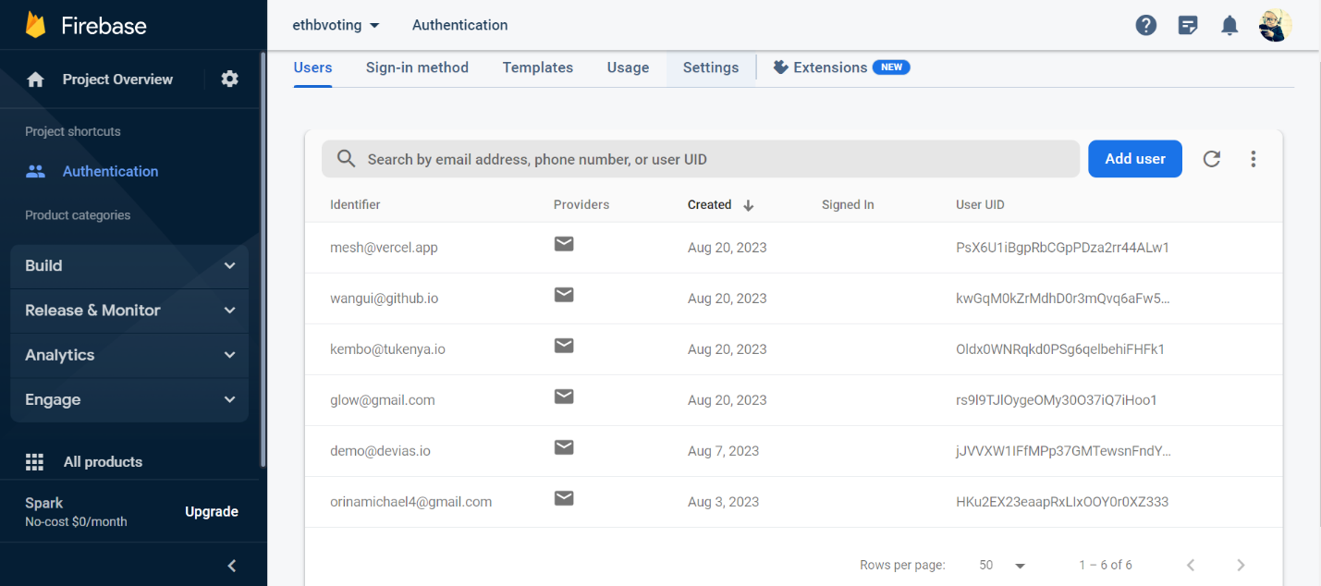

Figure :Test Data

## 6.6 Sample Run- Output

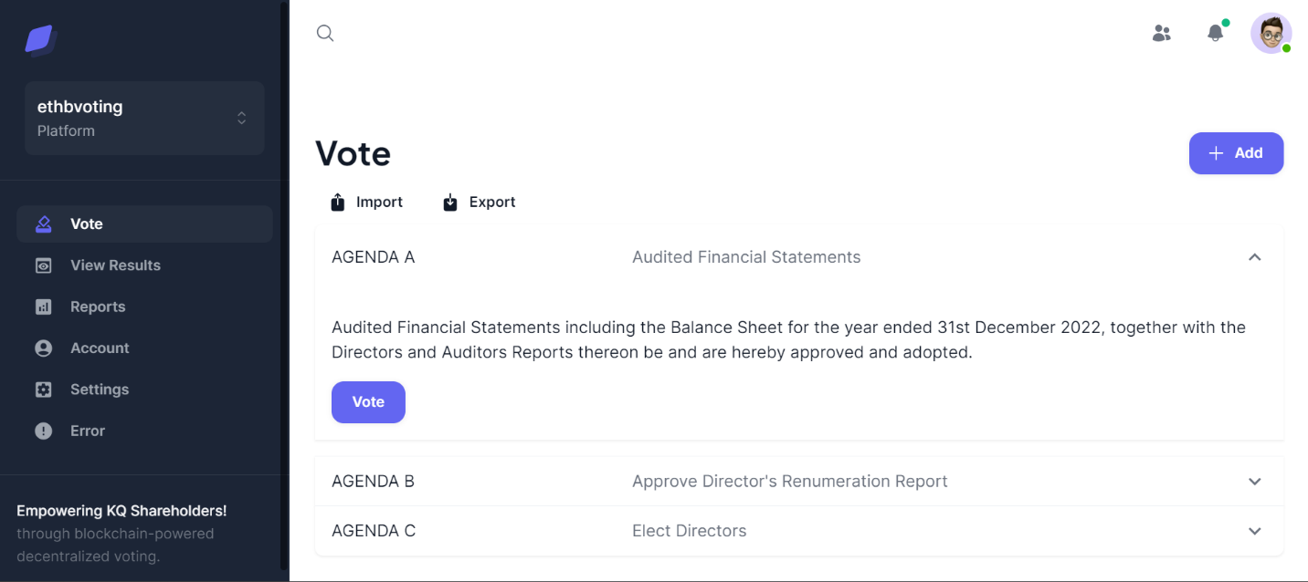

Figure :Sample Run Output

# CHAPTER SEVEN: USER MANUAL - DOCUMENTATION

## 7.1 Installation Environment

The project is designed to be accessed and used through standard web browsers. It does not require any specialized software installation.

## 7.2 Installation Requirements

**Web Browser:** Users need a standard web browser like Chrome, Firefox, Safari, or Edge to access the web application.

**Internet Connection:** Access to the internet is required for users to connect to and use the system.

**Security Measures:** Users should ensure they have updated antivirus and firewall software to maintain security while using the system.

**Device:** The system is accessible from various devices such as computers, laptops, tablets, and smartphones.

**User Accounts:** Users will need valid login credentials provided by Kenya Airways to access the voting system.

## 7.3 Installation Procedures

Shareholders only need to open a standard web browser, enter the system's web address, log in using provided credentials, cast their votes using the user-friendly interface, confirm, and log out.

## 7.4 User Instructions

This are the instruction and procedure to be followed on how to use the system.

### 7.4.1 User login to the platform

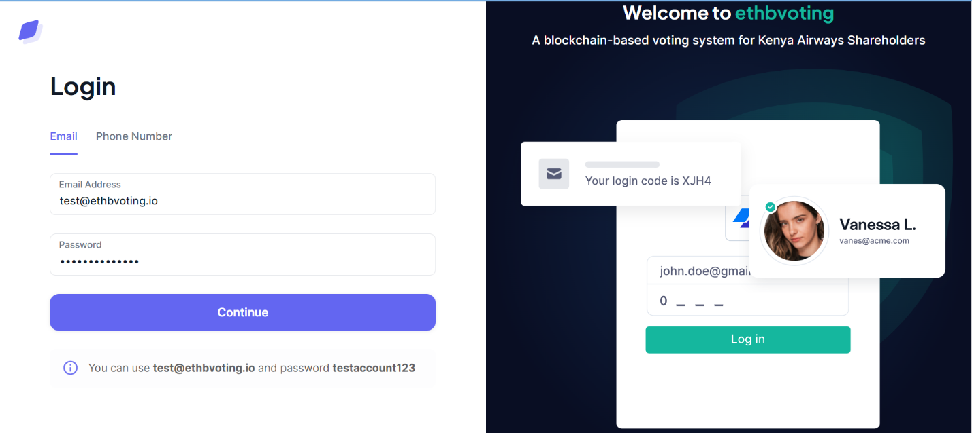

Figure : User Login Page

The shareholders are given login details to login into the system and vote.

### 7.4.2 Home page

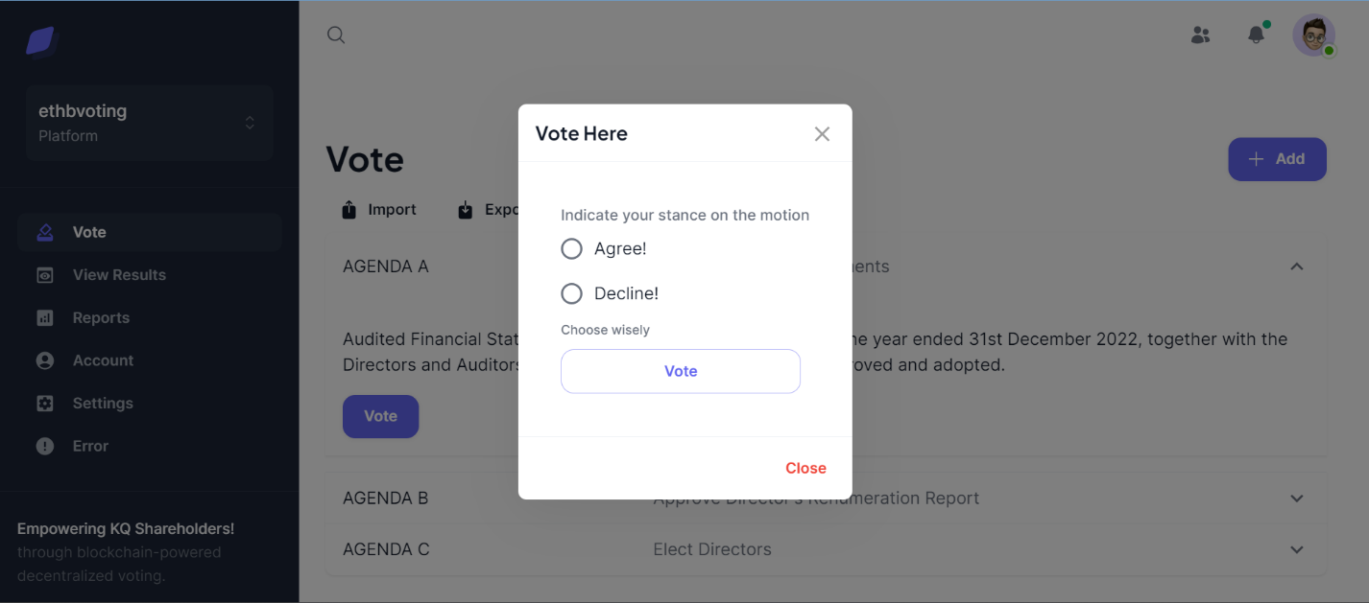

Figure : User Voting Page

The screenshot above is the vote page where shareholders vote on respective matters.

### 7.4.3 User view results

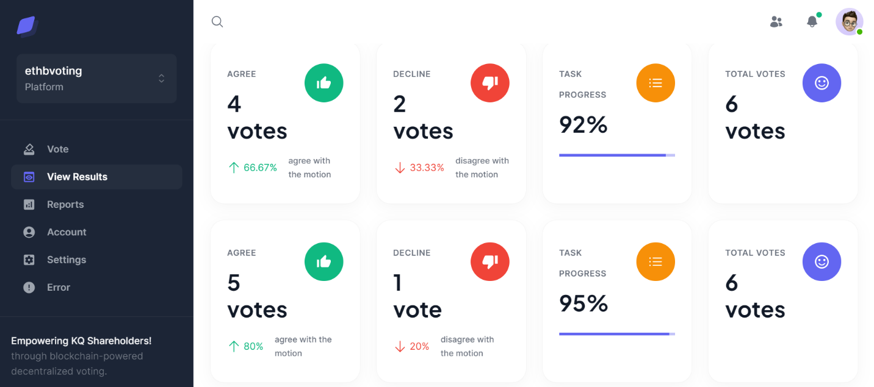

Figure : User View Results Page

### 7.4.4 User generate reports

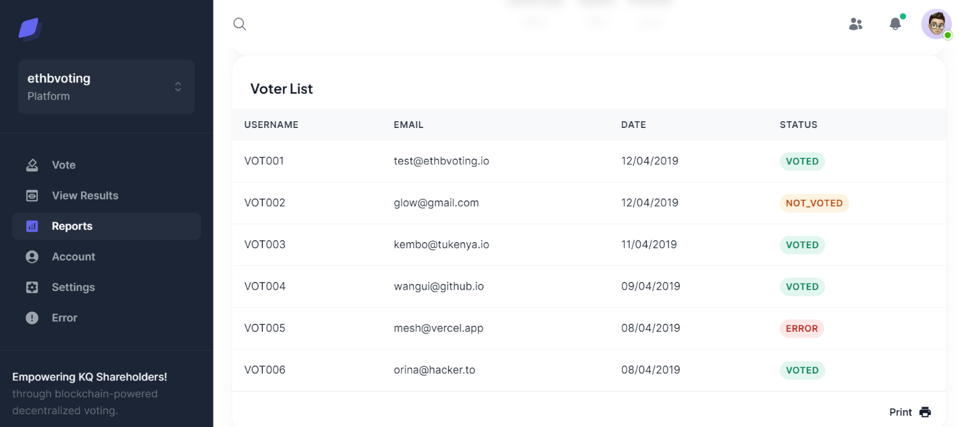

Figure : User Report Page

### 7.4.5 User’s profile

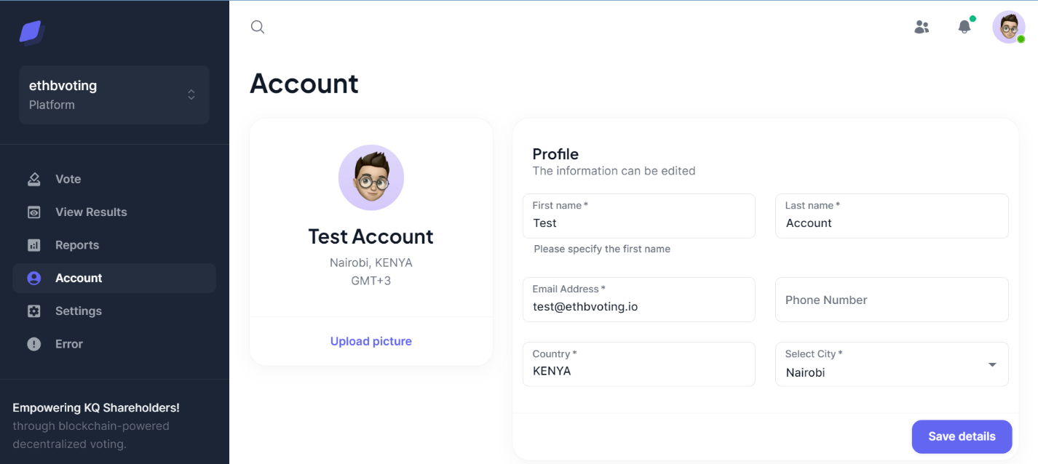

Figure : User Profile Page

Shareholders can update their profiles on this account page.

### 7.4.6 Settings

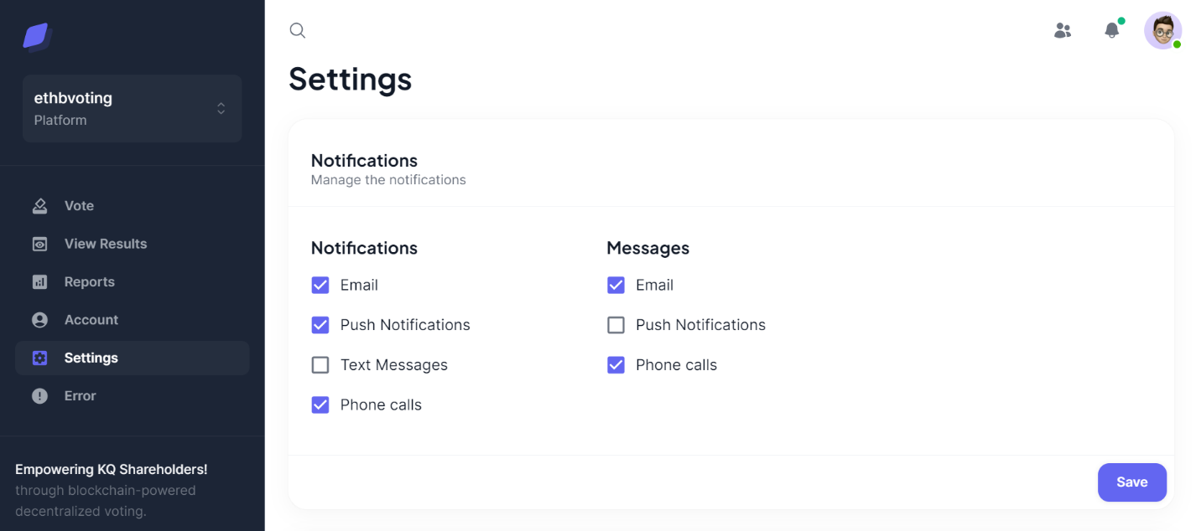

Figure : User Settings Page

## 7.5 System Conversion Method

In reference to Mallach (2009), there exist various conversion methods for new systems and application. They system conversion strategies include direct changeover and parallel changeover. For this application direct changeover also called direct conversion method will be used. This is because there will be no disrupted operations if the system fails because tests have been done.

## 7.6 User Training

Users will receive training that introduces them to the system's purpose and benefits. They'll learn how to log in, move around the system, vote safely, and log out. We'll also cover common issues and how to get help if needed. This training will make sure users feel comfortable and secure while using the system to vote.

## 7.7 File Conversions

Information about the users will be collected from the Kenya Airways Shareholder’s Database. Hence no file conversions are required.

# CHAPTER EIGHT: LIMITATIONS, CHALLENGES, CONCLUSIONS AND RECOMMENDATIONS.

## 8.1 Limitations

Just like any other system, similarly ethbvoting had some limitations. The following are some of the features which are limitations:

* Encouraging all shareholders to adopt the new system may take time due to habits and preferences.
* The time factor is a limitation; thus, I was not able to achieve all the functionalities of the application within the given time since some features have a large learning curve.
* Generating reports in PDF format.

## 8.2 Challenges

During the development process I faced some challenges;

1. Integrating blockchain technology requires expertise in cryptography and blockchain protocols
2. Designing an intuitive and user-friendly interface that accommodates various user preferences
3. Creating secure and efficient smart contracts to facilitate voting processes demands thorough understanding of Solidity and blockchain development.

## 8.3 Degree of success

The project was a success this is because most of its basic functionalities were implemented. In addition, it laid down the basis for future improvements which will be made based on the skills and experience gathered during this project development process.

## 8.4 Learning experience

Creating the blockchain-based voting system for Kenya Airways shareholders has been an enlightening journey. Navigating blockchain intricacies, security, scalability, and legal considerations has deepened my project management and innovation insights. This experience emphasizes the value of interdisciplinary collaboration and ongoing learning in driving impactful solutions.

## 8.5 Recommendations

ethbvoting is still a long way from being commercially viable as a product. I recommend the following for future versions:

1. **Multi-Language Support:** Introduce support for multiple languages to cater to a diverse group of shareholders.
2. **Mobile App Integration:** Develop a mobile app version for convenient voting on smartphones and tablets.

## 8.6 Conclusion

To sum up, the blockchain-based voting system for Kenya Airways shareholders is a smart blend of technology and real-world needs. The system's design and testing show that it can make voting easier and more honest. By using this system, shareholders can be more involved in decision-making and trust the process. With thoughtful planning and user-friendly guidance, this system promises to change how we all work together for the better.

# REFERENCES

Kshetri, N. (2017). Can blockchain strengthen the internet of things? IT Professional, 19(4), 68-72.

Johnson, M. P. (2018). Design and implementation of a secure blockchain-based electronic voting system. In Proceedings of the International Conference on Computational Science and Computational Intelligence (pp. 18-23).

Chen, C. S., & Liao, Y. H. (2018). Development of a blockchain-based e-voting system: Design and implementation. In Proceedings of the IEEE/RSJ International Conference on Intelligent Robots and Systems (IROS) (pp. 6224-6230).

Sasaki, H., Mori, K., & Matsuo, K. (2018). Blockchain-based secure voting system. In Proceedings of the International Conference on Smart Grid and Blockchain (pp. 175-180).

Pop, C., & Toma, C. (2019). Using blockchain technology for secure electronic voting. In Proceedings of the International Conference on Security for Information Technology and Communications (pp. 79-91).

Mylrea, M. E. (2019). Blockchain voting systems: Can democracy be hacked? IEEE Security & Privacy, 17(5), 85-89.

Smith, J. A. (2020). Blockchain technology in corporate governance: Enhancing shareholder participation and transparency. Corporate Governance: An International Review, 28(4), 203-218.

Özdemir, S., & Sari, A. (2020). A survey on blockchain-based voting systems. Computer Networks, 175, 107285.

"Kenya Airways Ltd." (2021). In Wikipedia. Retrieved September 17, 2021, from <https://en.wikipedia.org/wiki/Kenya_Airways>

# APPENDIX

## PRINT CODES



Figure : Print Code 1

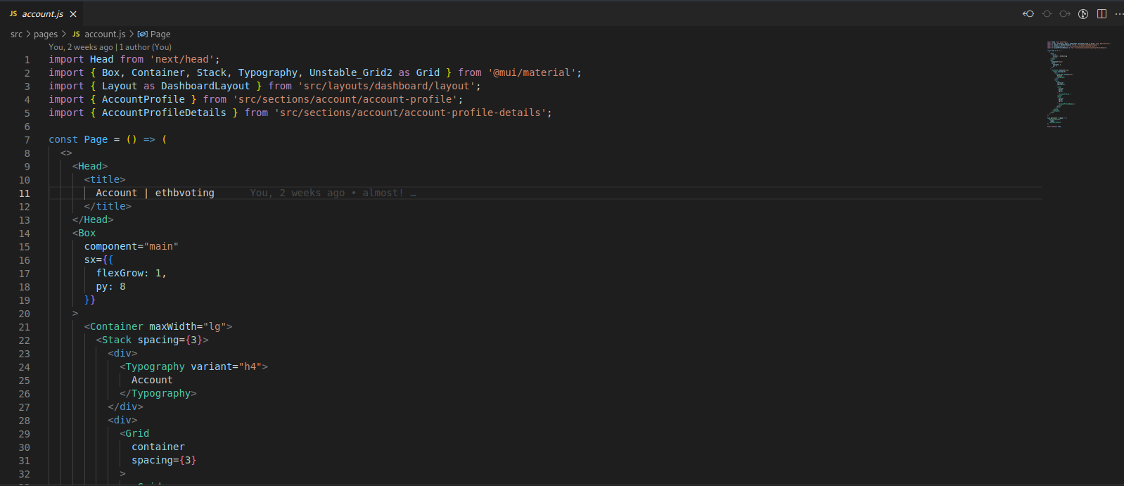

Figure : Print Code 2

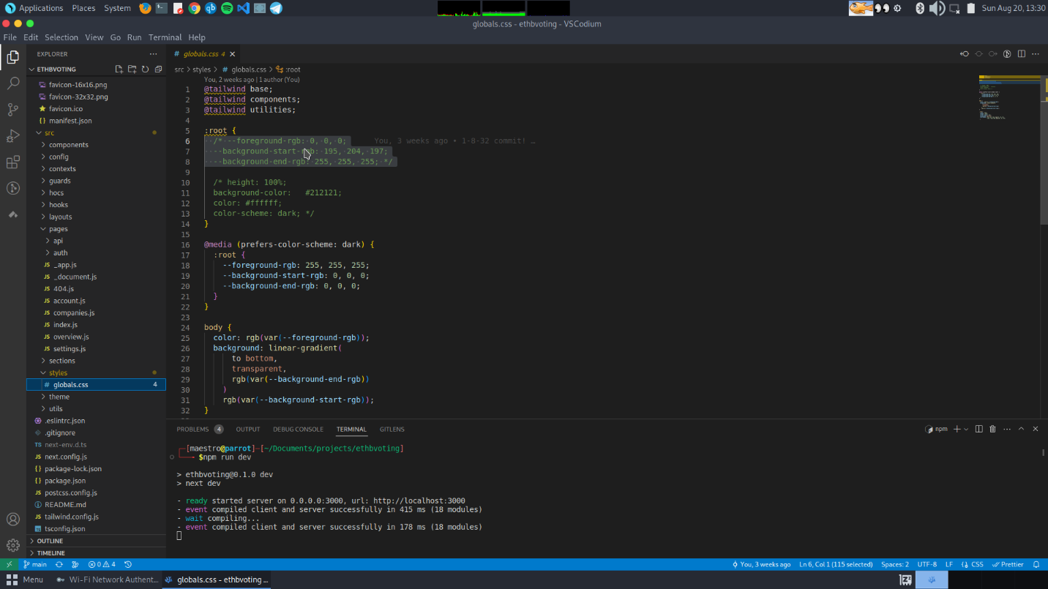

Figure : Print Code 3

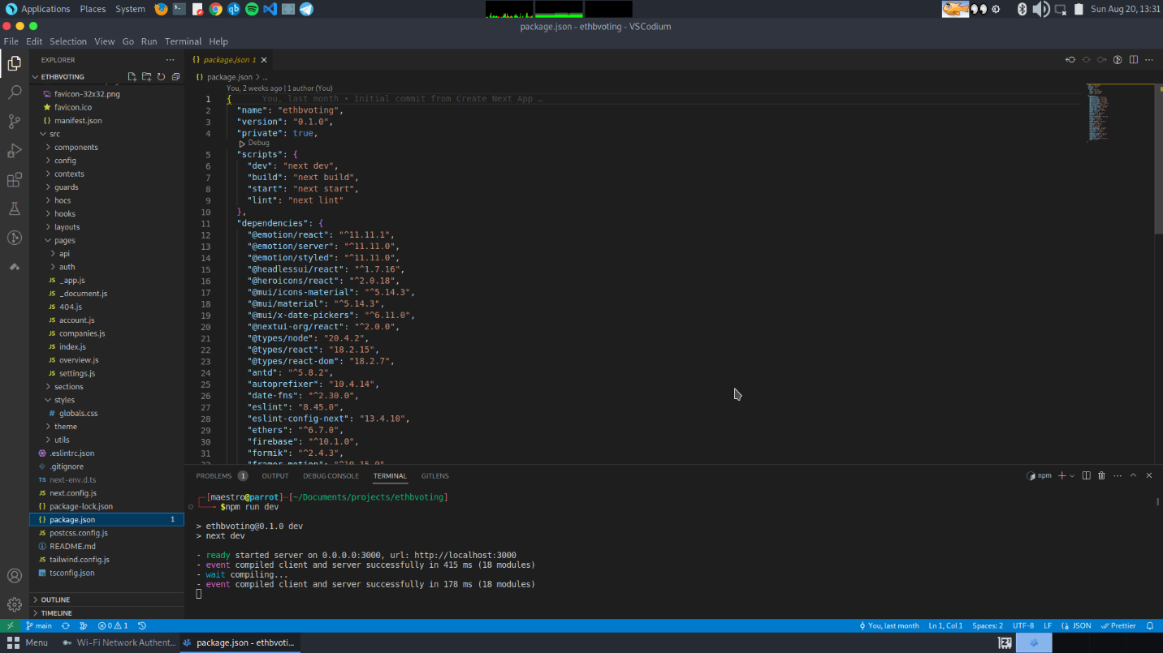

Figure : Print Code 4